Genetic Engineering Practice Exam Question
(A) Plasmids are often used as vectors in genetic engineering.
(i) What is the role of a vector?
...........................................................................................................................................
...........................................................................................................................................
(1)
(ii) Describe the role of restriction endonucleases in the formation of plasmids that
donor DNA.

...........................................................................................................................................
...........................................................................................................................................
...........................................................................................................................................
...........................................................................................................................................
(2)
(iii) Describe the role of DNA ligase in the production of plasmids containing donor DNA.
...........................................................................................................................................
...........................................................................................................................................
(1)
(B) There are many different restriction endonucleases. Each type cuts the DNA of a plasmid at a specific base sequence called a restriction site. The diagram shows the position of four restriction sites, J, K, L and M, for four different enzymes on a single plasmid. The distances between these sites is measured in kilobases of DNA.
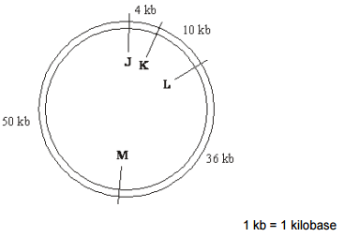

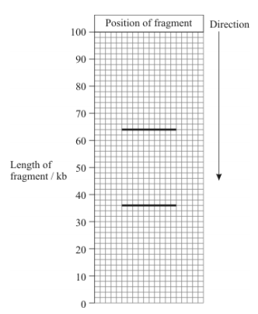
The plasmid was cut using only two restriction endonucleases. The resulting fragments were separated by gel electrophoresis. The positions of the fragments are shown in the chart below.
(i) Which of the restriction sites were cut?

...........................................................................................................................................
(1)
(ii) Explain your answer.
...........................................................................................................................................
...........................................................................................................................................
(1)
Total (6 marks)

